A000-PAC-Poly-Easter Island-Moai Kavakava-Bird-men-19th c

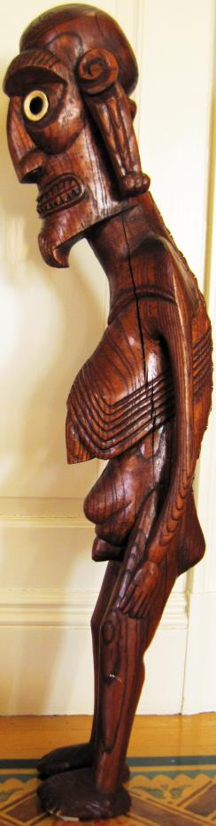

*Moai Kavakava*, Atlantika Collection, 37 in. tall

Case No.: 13

**Accession No.**

**Formal Label:** PAC-Poly-Easter Island-Moai Kavakava-Bird-men-19th c

**Display Description:**

Easter Island or Rapanui, so named by Dutch explorer Jacob Roggeveen, who encountered it on Easter Sunday 1722, is the most isolated inhabited island on Earth, with its closest inhabited neighbor, Pitcairn Island, 2,075 km (1,289 mi) to the west. When the first settlers arrived from Nuku Hiva between 300 CE and 800 CE under the legendary leader Hotu Matu'a, they landed at Anakena Beach and subdivided the island into Ahu Pua'a or pie-shaped slices extending from the coast to the volcanic peaks to assure that each group of settlers would have access to all resources, from the sea to the mountains. Initially, it was a paradise, but it was unexpectedly fragile.

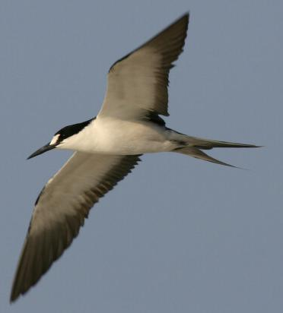

Sooty-tern in flight illustrating its split tail. After http://www.outdoorcentral.com/articles/wp-content/uploads/2008/09/20080917007.jpg.

And so athletic youths lined up to climb down the steep volcanic cliffs of Orongo, to swim across the shark infested waters to the sooty-tern breeding grounds of Moto Nui and to return with the first fruits of the year--the first of the eggs of the sooty-tern that symbolized hope for the future of the island.

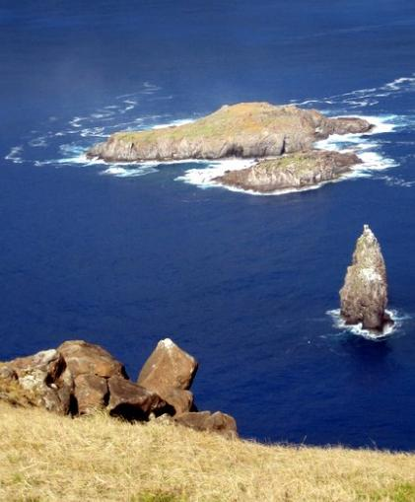

Moto Nui as seen from Orongo. After http://upload.wikimedia.org/wikipedia/commons/2/29/Rano-Kau-2b-Birdman-Cult.JPG

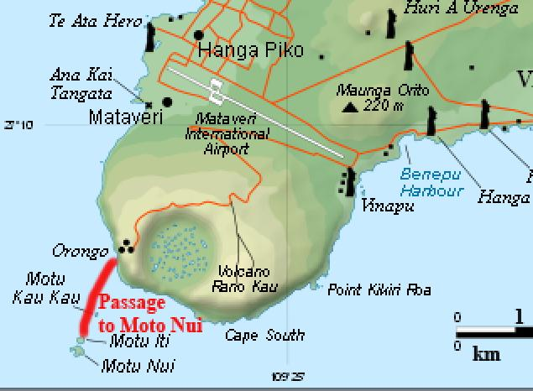

Easter Island after http://upload.wikimedia.org/wikipedia/commons/thumb/b/bc/Easter_Island_map-en.svg/250px-Easter_Island_map-en.svg.png.

The egg of the sooty tern became a symbol of new life. if only the ancestors would acknowledge this effort and intercede with the forces of nature. How ironic on "Easter" Island. Eggs were carved from driftwood with double-headed images of the sooty-tern incised on them or with their egg gatherers emerging from them as new hatchlings. These eggs were called "*Tahonga.*" The two heads possibly indicated the outward journey and return from the sooty-tern island. In any case the Janus-like figures reinforced the concept of looking outwardly and looking inwardly. How psychologically appropriate for the dire ecological disaster with which the islanders were faced.

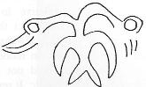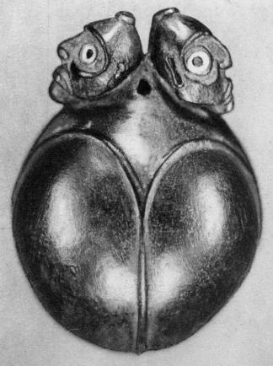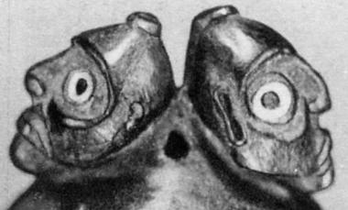

Left: bicephalic avian motif on a *Tahonga* or egg-shaped pendant in the collection of the Padri Dei Sacri Cuori, Rome (Foment 1993:207). Right: a *Tahonga* , 6 in. high, illustrating its egg-shape and dual cephalus with detail of bearded figures with shark vertebrae and obsidian eyes from *Sophora toromiro* (Chauvet 2004 [1935], Fig. 94.

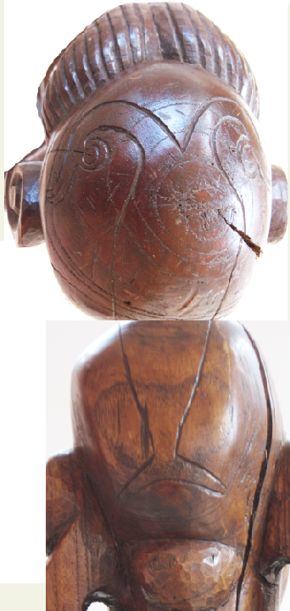

The double-headed sooty-tern image on the top of the

*Moai Kavakava* head.

The *Moai kavakava* or "ribbed statue" in the Rapanui language depicts an aged man who had, in his youth, succeeded in being one of the first to acquire the egg of the sooty tern from the islet of Moto Nui and to swim back with it to the southwest coast of Rapa Nui. There, on the southwest promontory of Orongo on Rapa Nui, he was made Bird-Man or *Hopu* of the year. The bald head of this *Hopu* has the tattoo of a double-headed sooty tern as this badge of office for a year, since, in Polynesia, the top of the head was considered the seat of spiritual power. The double-headed sooty tern indicates the spiritual history of the Rapa Nui Polynesians, which looks back to the past transgressions of the people and forward to the future atonement made by the yearly *Hopu*. This statue is carved from indigenous hardwood of the *toromiro* tree. The eyes are wide-open as symbols indicative of a visionary, similar in intent to the peering eyes of the basalt *Moai*. The whites of the eyes are of the vertebrae of the great white shark, and the pupils are of obsidian from one of the three volcanoes on the island. This statue stands slightly off-balance and displays emaciated ribs and a protruding spine to accentuate selfless starvation as a further atonement for the people. Elongated ears denote his elevated status as an *ali'I* or revered wise, champion bird-man or *Hopu*, who had once risked his life in a symbolic effort to atone for his people’s transgressions. No longer able to repeat the feat of securing the symbolic sooty tern egg, this *Hopu* now stands as a mute sentinel as the once and future champion of his people.

Coconut trees no longer existed on the island to carry the heavy statues to the seacoast, so another carving tradition was developed, the *Moai Kavakava* or "ribbed statue" in the language of Polynesian Rapanui. Carved from indigenous wood of the *toromiro* hardwood tree, its eyes were carved white shark vertebrae and black obsidian for the pupils, were the symbols of a clear-seeing visionary like the athletic Bird-men who could swim in shark-infested waters to gather the prized sooty-tern eggs,

These *Moai Kavakava* are the aged versions of the once athletic *Hopu,* the Birdmen, who now stand slightly off balance with emaciated ribs and protruding spines to accentuate not only their age but also the sacrifice the islands have made in their continuing starvation.

Elongated ears denote their elevated *ali'i* status. Their head tattoos denote their championship accomplishment of youth. For these are the ancient ones who were once the champion bird-men, the *Hopu*, the ones who had risked their lives to save their people. No longer able to accomplish the feat of securing the symbolic sooty tern egg, they now stand as mute sentinels as once and future champions of their people -- a hope in the future reflecting the sacrifices they had made in their youth.

**LC Classification:** F3169 F48

Date or Time Horizon: c 1200 CE

Geographical Area: Rapa Nui

**Map:**

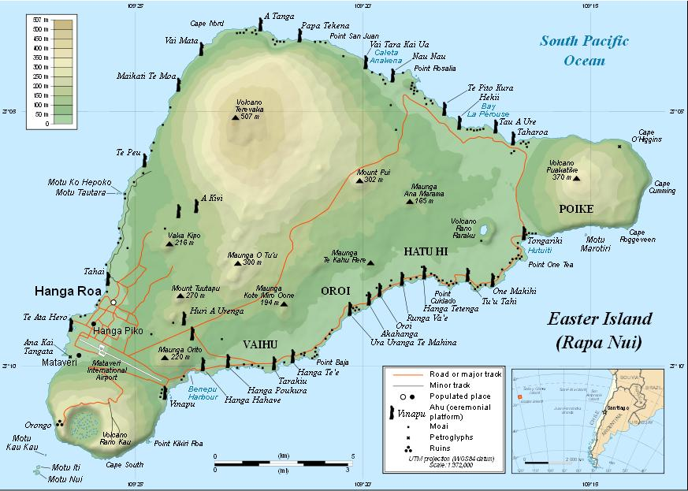

**GPS coordinates:**

**Cultural Affiliation: Polynesian, Rapa Nui**

**Media:**

**Dimensions:** 37 in. tall

**Weight:**

**Condition:**

**Provenance: Rapa Nui**

**Discussion:**

Easter Island or Rapanui, so named by Dutch explorer Jacob Roggeveen, who encountered it on Easter Sunday 1722, is the most isolated inhabited island on Earth, with its closest inhabited neighbor, Pitcairn Island, 2,075 km (1,289 mi) to the west. When the first settlers arrived from Nuku Hiva between 300 CE and 800 CE under the legendary leader Hotu Matu'a, they landed at Anakena Beach and subdivided the island into Ahu Pua'a or pie-shaped slices extending from the coast to the volcanic peaks to assure that each group of settlers would have access to all resources, from the sea to the mountains. Initially, it was a paradise, but it was unexpectedly fragile.

Able to flourish during the ensuing period that roughly corresponds to the Neo-Atlantic Altithermal Climatic Period (800-1200 CE) the island succumbed to the onset of a climatic downturn during the Pacific Climatic Period, when the growing season began to shorten and the rainfall lessened around 1250-1300 CE.

Easter Islanders thought this was due to their own transgressions against the gods, so they began to carve large stone statues from volcanic basalt and rolled these statues down to seaside platforms where they erected them as offerings to the ancestors, whom they believed they had in some way wronged with their actions.

Although the sculpting of these 887 statues or *Moai* (as they are called in Rapanui, the language of Easter Island) was difficult, the transportation of them to the seaside was disastrous as they needed coconut trees to roll them down the steep volcanic slopes. Some were placed facing seaward, while others were placed facing inland to watch over the people.

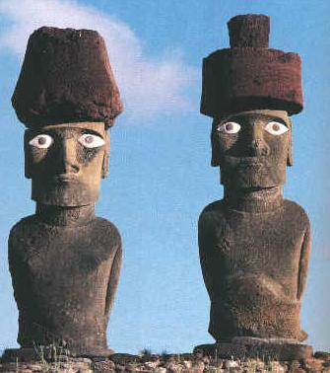 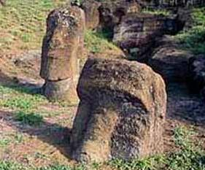

Left: Basalt Moai reconstructed showing the visual effect of scoria pupils set in bone eyes. After http://www.crystalinks.com/moai_eyes.jpg. right Moai buried up to their shoulders. After http://www.crystalinks.com/moaiburied.jpg.

The destruction of the coconut trees spelled the end of their once seemingly paradisal life, for once the last trees were cut there was no more wood for building rafts or boats and the people were imprisoned on their island and reduced to fishing from land. Food became scarce and the climate continued to worsen. In northern Europe this climatic downturn was known as the Little Ice Age. The *Moai* had forsaken the people. Tribal wars ensued and the *Moai* were toppled or buried.

The *ali'i* or elders believed another, more effective means of atonement was required from the ancestors if they were to survive. The people had noted the seasonal migratory flight of birds over their isolated island prison. Perhaps these were the ancestors scrutinizing their activities. So a new cult was developed by the *ali'i*. This was the cult of the bird man or *Tangatu Manu* in which each year the most adept athletes were enjoined to swim from the mainland at Orongo to an offshore islet, Moto Nui, were the sooty terns would lay their eggs. Sooty terns were pelagic birds and rarely sought land except to lay their eggs and rear their young.

**References:**

2004 [1935]. *Easter Island and Its Mysteries*, trans. A. M. Altman. Fig. 94, from http://www.chauvet-translation.com/index.htm.

HEYERDAHL, T. 1975. *The art of Easter Island*. New York: Doubleday, 1975.

FISCHER, S.R. (ed.). 1993. *Easter Island studies. Contributions to the history of Rapanui in memory of William T. Mulloy*. Oxford: Oxbow. Oxbow Monograph 32.

FOMENT, FRANCINA. 1993. "'You are Crab, Crayfish, and Octopus': Personal and Group Symbols in Rapanui Wood Sculpture," in Fischer (1993): 206-213.

ORLIAC, C. 1993. "Types of wood used in Rapanui carving," in Fischer (1993): 201-5.   
ORLIAC, C. & M. ORLIAC. 1995. *Bois sculptes de l'Ile de Paques*. Marseille: Editions Parentheses.

Appendix:

Sotheby's

November 16, 2008

Sale 8444

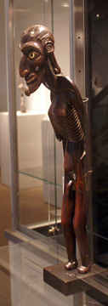

***Lot 94, Rapa Nui Male Figure, Easter Island, 16 1/2 inches high***

**By Carter B. Horsley**

The Fall 2008 auction of African, Oceanic and Pre-Columbian Art at Sotheby's is the spectacular and very important collection of Frieda and Milton Rosenthal who lived in Westchester County and bought many masterpieces from Helena Rubenstein, Nelson Rockefeller John J. Klejman.

The auction was extremely successful with 117 of 118 offered works selling for $10,859,944.

Lot 94 is a highly stylized and scrawny but "magnificent "Rapa Nui" male figure from Easter Island that is 16 1/2 inches high. It has an estimate of $250,000 to $350,000. **It sold for $614,500, including the buyer's premium as do all results mentioned in this article, an auction record for an Easter Island sculpture.**